Dokumentacia scanOrder

Autentifikacia

Login
Route: POST
url: /login
potrebuje:
email
password

Register Customer
Route:POST
url : /register/customer
potrebuje:
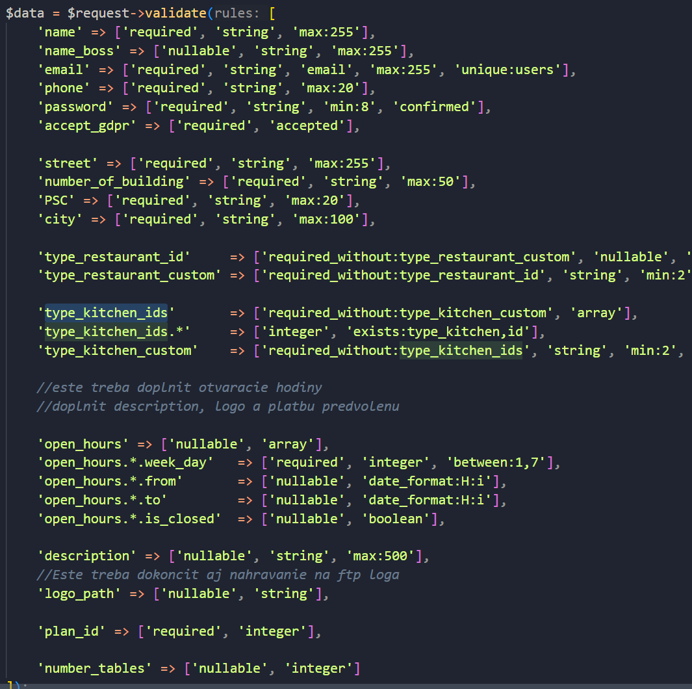
Ked tam je nullable pri tej premennej tak nie je povinna.
Ked tam je required tak je povinna.
Ked tam je required_without:xyz -> treba to ked nie je xyz.
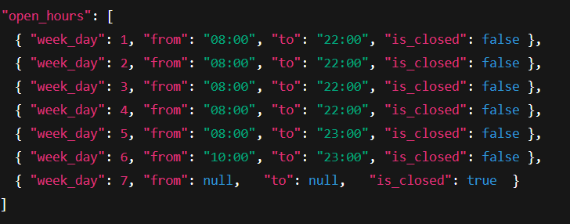
Takto posielat otvaracie hodiny by bolo

Register Restaurant
Route:POST
url: /register/restaurant
potrebuje: name, email,phone, password, password_confirmation, accept_gdpr,
street, number_of_building, PSC, city
volitelne: name_boss
specialny pripad: type_restaurant_id alebo type_restaurant_custom
type_kitchen_ids alebo type_kitchen_custom
tie custom su stringy novy nazov novy type restaurant alebo type kitchen

Logout
Route: POST
url: /logout
potrebuje: nic

